CHAPTER 4: Ecosystems
Worksheet 4.6

Cycles in nature
Science Quest 7: pages 122–127
Student: Class:

The nitrogen cycle
1. The following diagram summarises the nitrogen cycle in nature.
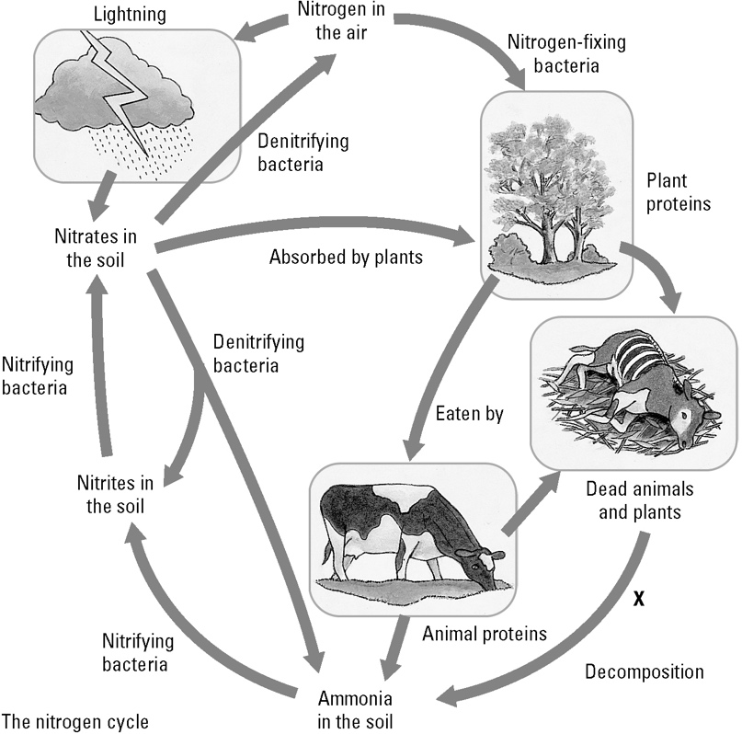 | (a) Explain why nitrogen is such an important chemical in nature.  (b) Identify two decomposers at point X.  (c) Identify the ways that ammonia can enter the soil.
(d) Explain why ammonia does not build up in the soil.

The recyclers
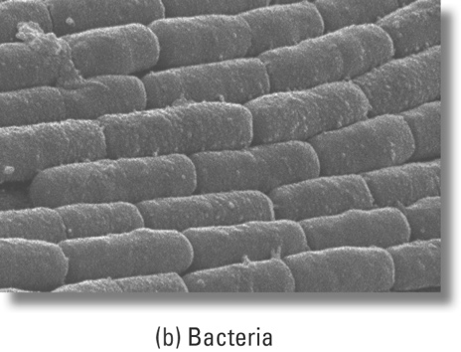
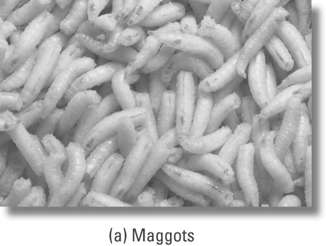

2. Matter and energy are recycled in nature. The nitrogen cycle, carbon cycle and water cycle are very important systems. These cycles involve living things as well as non-living things.
© Photolibrary/SPL/
Francoise Sauze
© Photolibrary/SPL/
Garry Watson
© Photolibrary/SPL/David Scharf
Explain the role of each of the decomposers shown in terms of recycling matter.

